4-H Online 2.0 Animal Entry Guide
Cat Project
*Note: For 4-H Members 8 and above

Log into 4-H Online

- Use your family email and password co.4honline.com

Click “View”, next to Member’s Name

Locating ‘Animals’
- Desktop, select “Animals” from the left side navigation

- Smart Phone or Tablet, click on the 3 bars in the top left corner
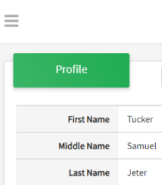
With either option, this will bring up a drop down list to begin adding Animals.

Adding an Animal
- Click "Add an Animal"
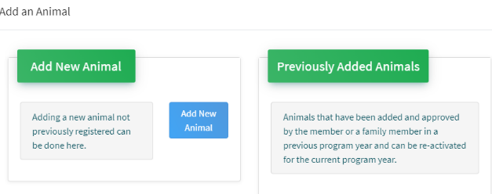Then select “Add New Animal”
- Select Cat, from the drop down. REQUIRED: Enter Animal’s Tag Number, click “Save”
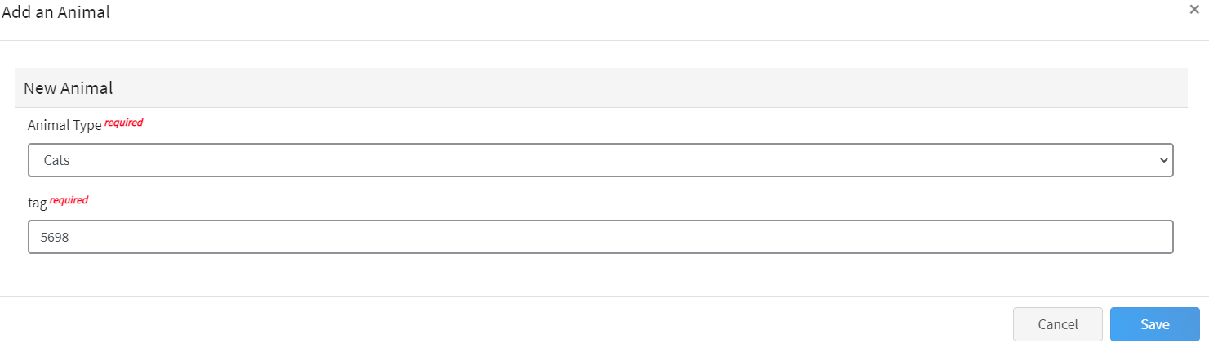
- Next, click “Show Questions”
Animal Entry is open for the current enrollment year. - Is all information complete? Check all county animal entry deadlines.
READ All County instructions for each animal species as county requirements vary.
- Enter the animal’s name.
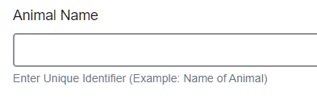
- Choose the breed from the drop-down box. Choose “other breed” or “mixed breed” if breed isn’t listed. ONLY select one breed.

- Fill in a description of the cat’s colors and markings.
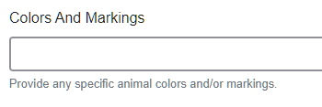
- Enter the FVRCP Vaccination Date
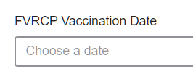
- Enter purchased or leased date
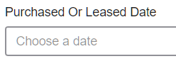
- Enter Rabies Tag and Vaccination Date
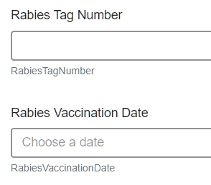
- Enter the registration information, if your cat is registered.
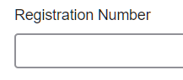
- Enter the Animal Gender – male or female.

- Enter whether or not the animal is spayed or neutered
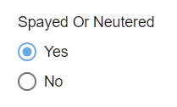
- The Tag number was carried over from first screen, enter Tattoo, if applicable.
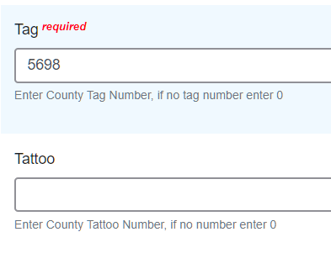
- Click “Next”, continue with the “File Uploads” that are required by your local county extension office. These will vary by county and species. Please follow your county guidelines.
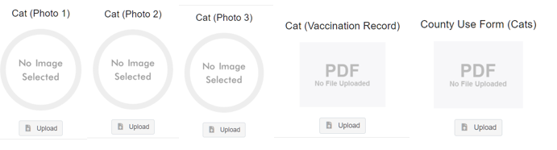
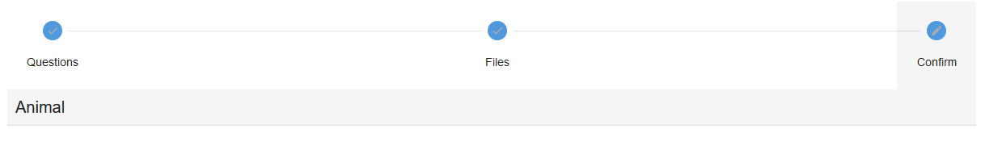
- Confirm all information, click ‘submit’
- County Extention staff, will review all information. If more is needed, members can edit. Once “Approved” by your local county extension office an email will be sent to your family account (example below) A time and date stamp for each animal.
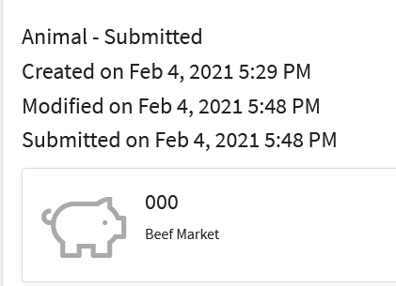
Questions, please contact your local extension staff.

